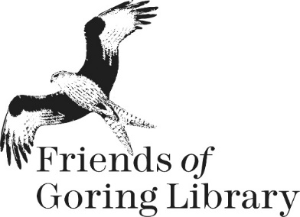
MEMBERSHIP FORM

Name(s) ____________________________________________________________

Address: ____________________________________________________________
____________________________________________________________

____________________________________________________________

Telephone: ______________________ E-mail: _______________________________

I would like to renew as (please tick as appropriate):

Individual member: £10 ______ Family member: £20 ______
(any number & combination of adults/children resident at the same address)

I would like to make an additional donation of: £________

Total enclosed: £___________

To pay with cash or by cheque (payable to Friends of Goring Library) please complete this form and deliver it, together with your payment, to the library.

Online payments (one-off or annual standing order) can be made to our account.
Name: Friends of Goring Library Sort Code: 30-92-93 Account Number: 68202568
If paying online please make sure that you put your name as the payment reference. Also, please complete this form (by editing the file) and e-mail it to FOGL.oxon@gmail.com.

Data Protection Declaration
I give the Friends of Goring Library permission to use the information I have supplied to them in the following ways:
- To store it securely for membership purposes
- To communicate with me as a member of the Friends of Goring Library
- To book onto events where OCC staff may see contact details
- To communicate externally with HMRC for Gift Aid claims when applicable

I consent to my data being used for membership purposes as detailed above.

Signed ………………………………………………. Dated .……………………………………………….

Signed ………………………………………………. Dated .………………………………………………

